Burnside Primary School
Parent Council – HT Report 31st August 2026
Staffing Updates
Welcome to our staff members this session. We have 2 Newly Qualified Teachers, Mrs. Clare McCall and Miss Alex McInulty, teaching P2 and P5. We also have a new School Support Assistant (SSA), Mrs. Beth Warnock. We are delighted that they are part of our team!
Our SSA Team Leader, Emma Murray, leaves us temporarily in a couple of weeks to go on maternity leave. We wish her all the best at this exciting time. The temporary post is currently advertised, and I will let you know as soon as I can the outcome of this recruitment.
Mrs. Tricia McDowall, SSA at Burnside for the past 23 years, left us on Friday to begin her retirement. Mrs McDowall has helped hundreds of children over the years, and we will really miss her. All the best for a long and happy retirement!
Our new P1s
Our brand-new cohort of Burnside Butterflies are off to a flying start at school. They have settled into our school routines and are learning how to follow our school expectations of being safe, kind and responsible. They are mastering our Lovely Lines and Wonderful Walking too!
Participatory Budgeting
At this time of year, we ask our whole community to help us decide how to spend a portion of our Pupil Equity Funding (PEF). We have around £2000 earmarked for this, and last year we spent this money on workshops with East Kilbride Arts Centre. Again, we would like to set up a committee with pupils, parents and staff represented. The committee will come up with 3 ideas, which will go out to the wider community to vote on. Please let me know if you would like to be involved.
Curriculum Improvement Cycle
As you may have heard on the news, the Scottish Curriculum is set to change, with full implementation in August 2028. Between now and then, draft guidance and samples will be trialled, and feedback collected. Scottish Government intends for there to be 2 additional in-service days this session for schools to work on this (one in Autumn, one in Spring), and these dates have yet to be announced.
For the most up-to-date information, please visit: Curriculum Improvement Cycle – Education Scotland
School Improvement Priorities
We are at the start of a three-year school improvement cycle. For this year, we have identified 3 main priorities to work on:
- Increase attainment in writing
- Continuous provision in classrooms
- Refresh Vision, Values and Aims
You can see how we plan for these strategic priorities to evolve over the 3-year cycle:
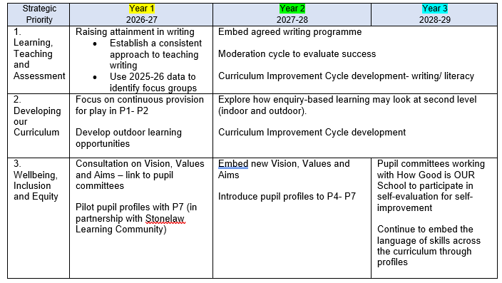
Our working parties will focus on writing, and continuous provision (indoor and outdoor) this year.
Outdoor Classroom
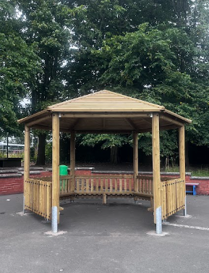
Finally, a thank you to you all for helping us to buy our new outdoor classroom. It is a perfect addition to the playground, provides shelter for up to a whole class, and is already well used at playtimes and lunchtimes. Here it is, in position:
